FABRICACIÓN DIGITAL:

* <https://cad.onshape.com/documents/324599d376e0bb24a7037670/w/6bf4f5778efd10bae7497164/e/251da6a82bb30a0c3f971ca7>

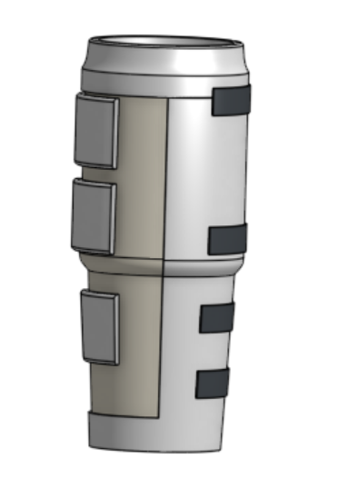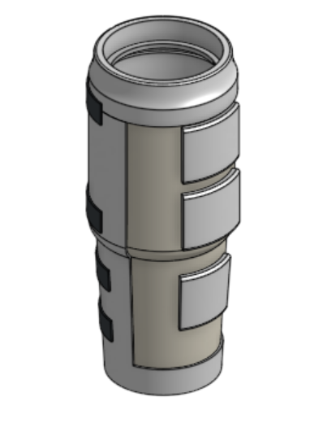

* <https://cad.onshape.com/documents/c9e9faccde90f447c459033d/w/0f56a14b06ccdf3cdb812858/e/1d4d8d4d7a2dbdb903b08014?renderMode=0&uiState=6901b24d25817a49e916b322>

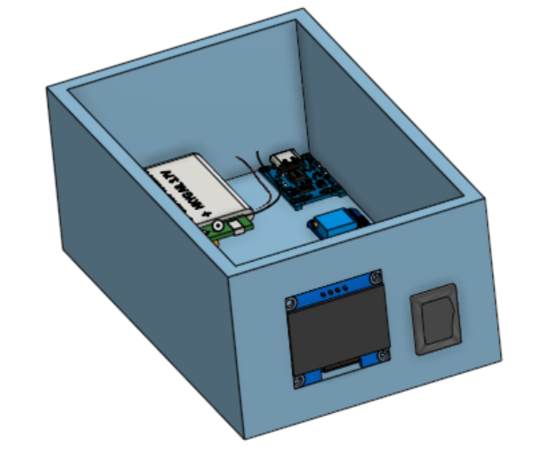

* <https://cad.onshape.com/documents/92ae4219a04bd6f2e99a09a0/w/fa90472f114d2e1da079a19a/e/66913019fc38d72ce8fed781>

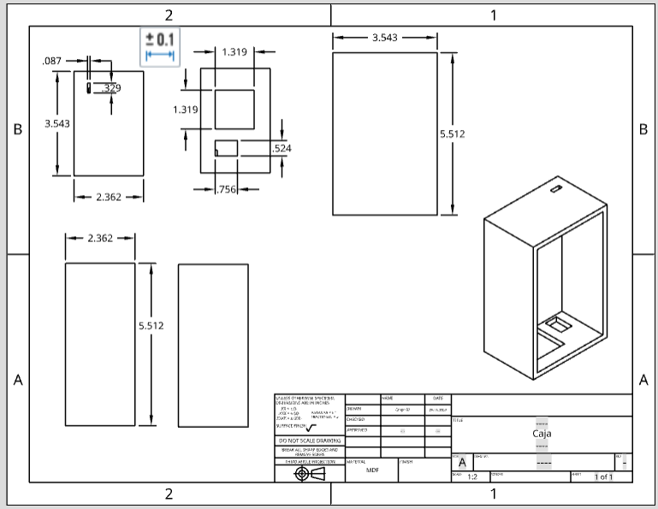

* <https://cad.onshape.com/documents/c9e9faccde90f447c459033d/w/0f56a14b06ccdf3cdb812858/e/0bfe0bd3690480e987f4f445?renderMode=0&uiState=6901b33025817a49e916b880>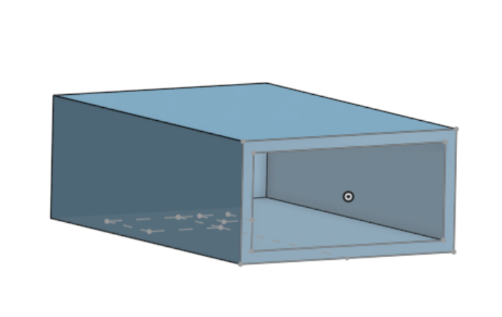
* <https://cad.onshape.com/documents/2b0cf6c3cd9debe94d8f9ce2/w/97b368ccfe43ae54360c5329/e/99a6025318e4ed5077670203>

